**Assignment 2**

1. Write a program in Python to perform the following operation:

* If a number is divisible by 3 it should print “Consultadd” as a string
* If a number is divisible by 5 it should print “c” as a string
* If a number is divisible by both 3 and 5 it should print “Consultadd Python Training” as a string.

**a=int(input("Please enter a number divisible by 3 or 5 - " ))**

**if a%5==0 and a%3==0:**

**print("Consultadd Python Training ")**

**elif a%3==0 :**

**print("Consultadd")**

**elif a%5==0 :**

**print("c")**

**else:**

**print("Please enter a number divisible by 3 or 5")**

2. Write a program in Python to perform the following operator based task:

* Ask user to choose the following option first:
  + If User Enter 1 - Addition
  + If User Enter 2 - Subtraction
  + If User Enter 3 - Division
  + If USer Enter 4 - Multiplication
  + If User Enter 5 - Average
* Ask the user to enter the 2 numbers in a variable for first and second for the first 4 options mentioned above.
* Ask the user to enter two more numbers as first1 and second2 for calculating the average as soon as the user chooses an option 5.
* At the end if the answer of any operation is Negative print a statement saying “zsa”
* NOTE: At a time users can perform one action at a time.

print("Please enter two variables ")

a=int(input("Please enter First number "))

b=int(input("Please enter Second number "))

print("Enter 1 for Addition")

print("Enter 2 for Subtraction")

print("Enter 3 for Division")

print("Enter 4 for Multiplication")

print("Enter 5 for Average")

print("Enter 6 to exit ")

while True:

c=int(input("Please selelct any number mentioned above to performe the action " ))

if c==1:

d=a+b

print("the result is ",d)

if c==2:

d=a-b

print("the result is ",d)

if d<0:

print("ZSA")

elif c==3:

d=a/b

print("the result is ",d)

elif c==5:

f=int(input("please enter first1 number "))

s=int(input("please enter second2 number "))

d=(a+b+f+s)/2

print("this is the average of four numbers you entered ",d)

elif c==4:

d=a*b

print("the result is ",d)

continue

elif c==6:

print("Thank you for playing the game ")

break

3. Write a program in Python to implement the given flowchart:

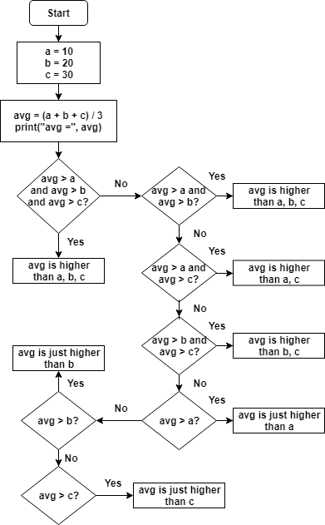

**a=10**

**b=20**

**c=30**

**avg=(a+b+c)/3**

**print("avg = ", avg)**

**if avg>a and avg>b and avg>c:**

**print("avg is higher than a,b,c")**

**elif avg>a and avg>b:**

**print("avg is higher than a,b,c")**

**elif avg>a and avg>c:**

**print ("avg is higher than a,c")**

**elif avg>b and avg >c:**

**print("avg is higher than b,c")**

**elif avg>a:**

**print("avg is just higher than a")**

**elif avg>b:**

**print("avg is just higher than b ")**

**elif avg>c:**

**print("avg is just higher than c")**

4. Write a program in Python to break and continue if the following cases occurs:

* If user enters a negative number just break the loop and print “It’s Over”
* If user enters a positive number just continue in the loop and print “Good Going”

while True:

a=int(input("Please enter a number "))

if a>=0:

print("good going ")

continue

elif a<0:

print("It's over")

break

5. Write a program in Python which will find all such numbers which are divisible by 7 but are not a multiple of 5, between 2000 and 3200.

6. What is the output of the following code examples?

* x=123

for i in x:

print(i)

* i = 0

while i < 5:

print(i)

i += 1

if i == 3:

break

else:

print(“error”)

**Output : 0,1,2**

* count = 0

while True:

print(count)

count += 1

if count >= 5:

Break

**Output :- 0,1,2,3,4**

7. Write a program that prints all the numbers from 0 to 6 except 3 and 6.

Expected output: 0 1 2 4 5

Note: Use ‘continue’ statement

r=[]

b=[]

for i in range(7):

if i ==3 or i ==6:

r.append(i)

else:

b.append(i)

print(b)

print(r)

8. Write a program that accepts a string as an input from user and calculate the number of digits and letters.

Expected output: consul12

Letters 6

Digits 2

s=input("enrter the values ")

letter=0

digit=0

for i in s:

if (i.isalpha())== True:

letter+=1

print("Letter ",letter)

for i in s:

if (i.isdigit())== True:

digit+=1

print("Digit ",digit)

9. Read the two parts of the question below:

* Write a program such that it asks users to “guess the lucky number”. If the correct number is guessed the program stops, otherwise it continues forever.
* Modify the program so that it asks users whether they want to guess again each time. Use two variables, ‘number’ for the number and ‘answer’ for the answer to the question whether they want to continue guessing. The program stops if the user guesses the correct number or answers “no”. ( The program continues as long as a user has not answered “no” and has not guessed the correct number)

a=6

while True:

var=int(input("enter your lucky number "))

if var != a:

r=input("wrong answer do you want to play again ?")

if r=="yes":

continue

elif r=="no":

print("Thank you palying the game")

break

else:

print("you have guessed the right number ")

break

10. Write a program that asks five times to guess the lucky number. Use a while loop and a counter, such as

counter=1

While counter <= 5:

print(“Type in the”, counter, “number”

counter=counter+1

The program asks for five guesses (no matter whether the correct number was guessed or not). If the correct number is guessed, the program outputs “Good guess!”, otherwise it outputs “Try again!”. After the fifth guess it stops and prints “Game over!”.

counter=0

a=10

while counter<=5:

if counter==5:

print("this is your last chance ")

ans=int(input("Enter your lucky number "))

if ans==a:

print("Good guess")

if ans!=a and counter==5:

print("Game over ")

else:

print ("try again ")

counter+=1

11. In the previous question, insert “break” after the “Good guess!” print statement. “break” will terminate the while loop so that users do not have to continue guessing after they found the number. If the user does not guess the number at all, print “Sorry but that was not very successful”.

counter=0

a=10

while counter<=5:

if counter==5:

print("this is your last chance ")

ans=int(input("Enter your lucky number "))

if ans==a:

print("Good guess")

break

if ans!=a and counter==5:

print("Sorry but that was not very successful ")

else:

print ("try again ")

counter+=1